Evidence Output

T011:

Valid last name case.

Input Reborn in last name.

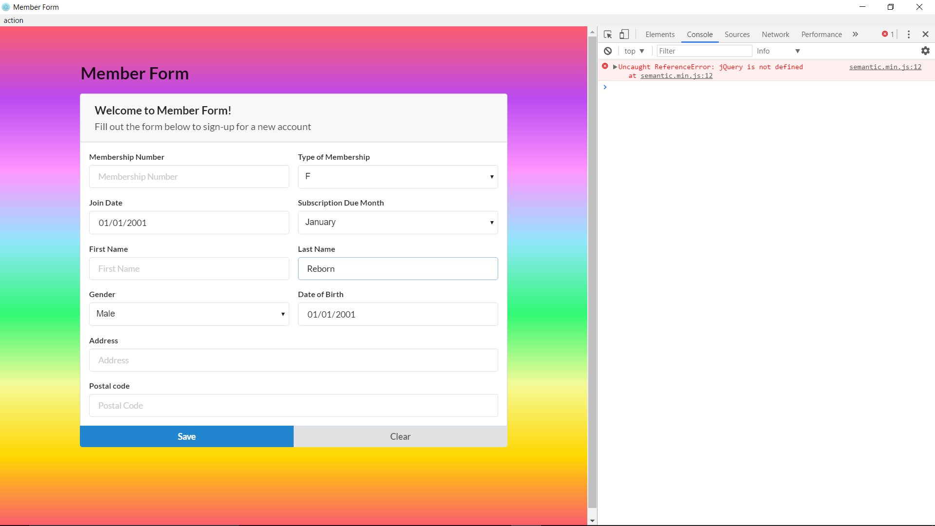

Valid first name case success.

